**Capstone Project Synopsis**

**Domain : Health Analytics**

**Use case : Potential of Medical Tourism in India**

* **Introduction**

Medical tourism refers to the process of traveling outside the country of residence for receiving medical care. In 2016 alone, approximately more than 200,000 tourists arrived on medical visa in India for their treatment and this number is increasing each year by 40-45%. The medical tourism industry of India in 2015 was estimated at US$3 billion & is projected to grow to $7-8 billion by 2020.

This phenomenon is a rapidly growing in today’s world. Medical tourists all over the world are seeking better opportunities for low cost and high quality treatment in other countries. Apart from India, Brazil, Mexico, Hungary are the other major medical tourism destinations in their respective geographies.

There are primarily 4 major reasons for India being a preferred destination

1. **Unavailability of Quality Healthcare in source Countries**

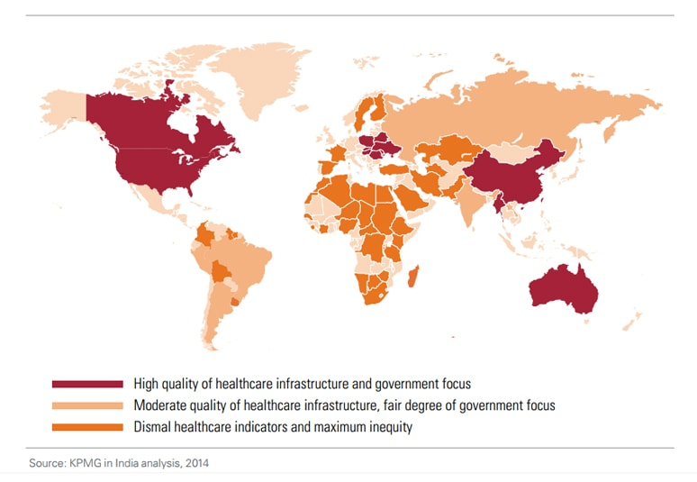

US, Europe, China, Korea and Australia have high quality of healthcare infrastructure. However, people in the developing and third world countries could typically not afford the high cost of treatment. This opens up a vast opportunity for the countries like India, Brazil etc with moderate degree of infrastructure and fair government focus facilitating revenues generation for the exchequer.

1. **High Affordability & Cost Effectiveness**

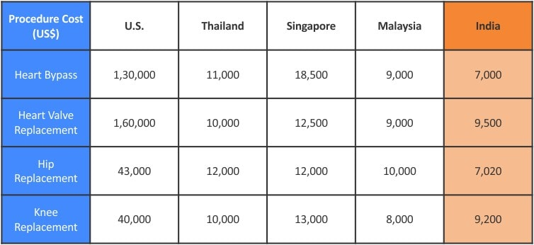

*Cost of various procedures in different countries* [[2]](https://www.frankit.in/blog/medical-tourism-successful-industry-in-india)

In terms of affordability and cost effectiveness, India is the most competitive even amongst the Asian countries.

1. **Indian doctors are highly renowned across the world for their skills and expertise.**

Most of the doctors and surgeons at Indian hospitals are trained or have worked at some of the medical institutions in the US, Europe, or other developed nations. Indian nurses are among the best in the world. Nearly 1000 recognized nurses-training centers in India, mostly attached to teaching hospitals, graduate nearly 10,000 nurses annually.

1. **World class infrastructure with friendly staff**

Top -of-the-line medical and diagnostic equipment from global international conglomerates is available at many Indian hospitals. This is coupled with English speaking Doctors, Nurses and support staff which is a major plus point from the communication perspective.

* **Scope and Objectives**

**The purpose of the project is to develop a predictive model to identify the potential of medical tourism in India. With this analytical model, hospitals and medical institutes in our country will be able to predict the expected inflow of patients from which all countries and for which all ailments in the near and distant future. This model will provide a leading input to the management of these medical institutes to build their short (2 years) and long (5 years) term strategies to harness the revenue potential envisaged from medical tourism.**

**In addition to the predictive model, the project would also entail benchmarking of India with other major medical tourism destinations like Brazil, Mexico and Hungary.**

* **Data Sources**

Data from different stakeholders in Medical tourism; medical tourists, hospitals, doctors and medical tour facilitators could be collected and their opinion would be analyzed to understand different perspectives of medical tourism as detailed in objectives and hypotheses of the study.

Some of the major data points which would be captured as primary and would also be created as secondary data sources are

* GDP of the developing and third world countries and projected growth rate for next 5 years
* Age of the population (%age of population in different age groups)
* Demography
* Ailments and their cost of treatment
* Population growth
* Medical institutes in India currently catering to medical tourism
* **Analytical Approach**

Will follow the approach of **Business -> Analytics Concepts -> Business.** Start with the business requirement, deploy the Analytical techniques learnt in solution building, testing and deployment and again evaluate it in the business context.

80:20 logic will be used in identifying the country and ailments for medical tourism.

Historical data and future trends will determine the variables critical for building the predictive model. Descriptive and analytical statistics would be used to derive inferences from the data. Both primary and secondary data would be used to present meaningful interpretations. To determine the factors impacting medical tourism, we would be using Principle Component Analysis / Factor Analysis. To predict the no. of patients a hospital is expected to have, we would be using logistic regression. Algorithms and model will be enriched based on the findings and business dynamics

* **References and Bibliography**

Why Medical Tourism is a Successful Industry in India <https://www.frankit.in/blog/medical-tourism-successful-industry-in-india>

Medical tourist arrivals in India up 25% <https://business-standard.com/article/companies/medical-tourist-arrivals-in-india-up-25-117041900577_1.html>

# India medical tourism statistics released [https://imtj.com/news/india-medical- tourism-statistics-released/](https://imtj.com/news/india-medical-tourism-statistics-released/)

# Ministry of Tourism <http://tourism.gov.in/wellness-medical-tourism>

# Evidence on global medical travel <http://who.int/bulletin/volumes/93/11/14-146027/en/>